SELECT c.contact_id, c.company_name, c.description, s.first_name, s.last_name, s.email

FROM campaign AS c

JOIN contacts AS s ON c.contact_id = s.contact_id

ORDER BY "contact_id";

SELECT c.contact_id, c.company_name, t.category_id, t.category, u.subcategory_id, u.subcategory

FROM campaign AS c

JOIN category AS t ON c.category_id = t.category_id

JOIN subcategory AS u ON c.subcategory_id = u.subcategory_id

ORDER BY "category_id";

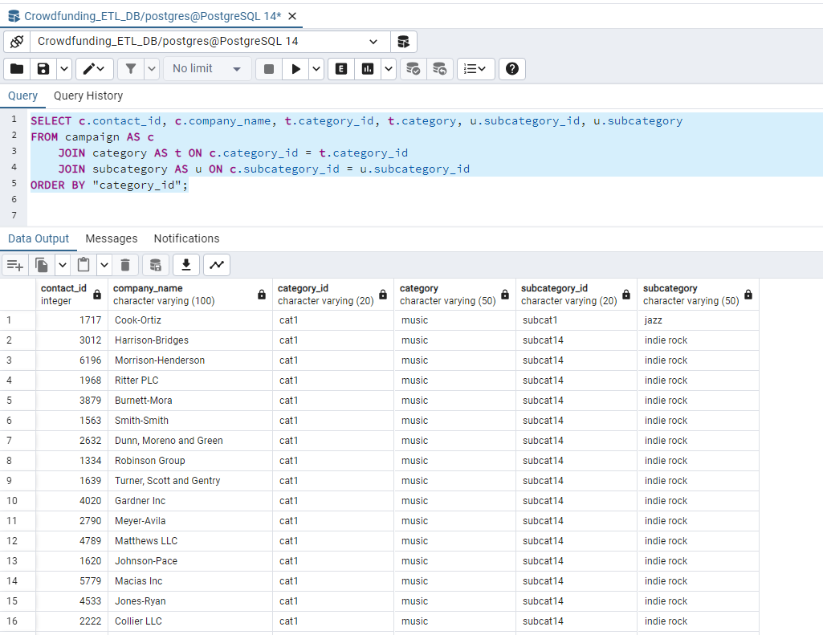

SELECT c.cf_id, c.contact_id, c.goal, c.pledged, s.first_name, s.last_name, t.category, u.subcategory

FROM campaign AS c

JOIN contacts AS s ON c.contact_id = s.contact_id

JOIN category AS t ON c.category_id = t.category_id

JOIN subcategory AS u ON c.subcategory_id = u.subcategory_id

ORDER BY "contact_id";

SELECT c.contact_id, c.company_name, t.category_id, t.category, u.subcategory_id, u.subcategory

FROM campaign AS c

JOIN contacts AS s ON c.contact_id = s.contact_id

JOIN category AS t ON c.category_id = t.category_id

JOIN subcategory AS u ON c.subcategory_id = u.subcategory_id

ORDER BY "category_id";

SELECT c.contact_id, c.company_name, c.description, s.first_name, s.last_name, s.email

FROM campaign AS c

JOIN contacts AS s ON c.contact_id = s.contact_id

ORDER BY "contact_id";

SELECT c.cf_id, c.contact_id, c.goal, c.pledged, s.first_name, s.last_name, t.category, u.subcategory

FROM campaign AS c

JOIN contacts AS s ON c.contact_id = s.contact_id

JOIN category AS t ON c.category_id = t.category_id

JOIN subcategory AS u ON c.subcategory_id = u.subcategory_id

ORDER BY "contact_id";

SELECT *

FROM campaign

SELECT *

FROM contacts

SELECT *

FROM category

SELECT *

FROM subcategory

